CITIZEN’S SUMMARY
Final Implementation Report

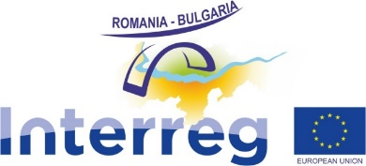

Introduction
The Interreg V-A Romania - Bulgaria Programme was approved by the European Commission in 2015 and aimed to promote cooperation between Romania and Bulgaria. This summary provides a citizen-friendly overview of the program's achievements, challenges and key results.

Program Highlights
- Funded 172 projects, of which 165 were successfully implemented and are fully operational, 3 projects were terminated and 4 projects were included in the list of non-functional projects and granted additional time for completion by the end of 2026, at the beneficiaries’ own funds.
- Invested in various areas like infrastructure, transport and accessibility, environment, safety, education, health and public services.
- Successfully navigated through the COVID-19 pandemic and the war in Ukraine challenges.
- Achieved its overall objectives and financial targets with an absorption rate of 97.54%.

Results by Priority Area
- PA 1: A Well-Connected Region: Modernized over 209 km of roads, improved Danube River navigation safety, and benefitted over 1.9 million people.
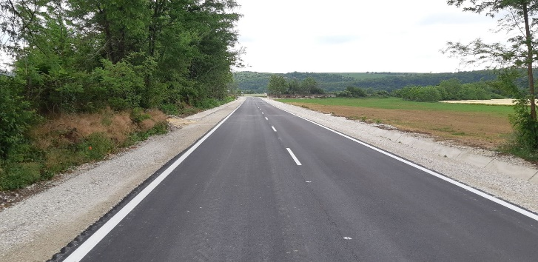
- PA 2: A Green Region: Implemented 66 projects focusing on sustainable use of cultural and natural heritage, creating tourism products, and valorizing natural resources. The value of the annual tourist overnights increased to approx. 8 million overnights in 2023.
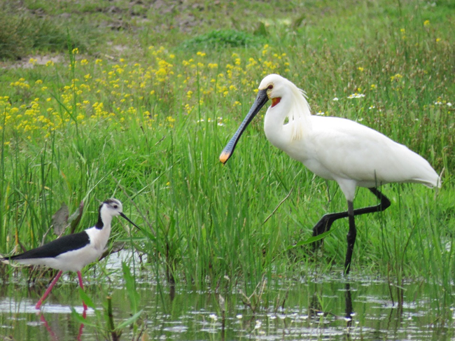
- PA 3: A Safe Region: Implemented 28 projects, enhancing fire-fighting and emergency response capacities, the entire population of the area, 3.9 million people benefited from actions on risk management, protection from floods and from forest fires.
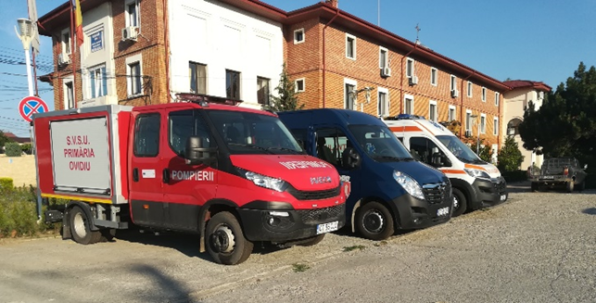
- PA 4: A Skilled and Inclusive Region: All 32 projects successfully completed, strengthening labor market collaboration and fostering connections between entrepreneurs across the border. Over 41,000 people participated in cross-border initiatives for jobs and training.
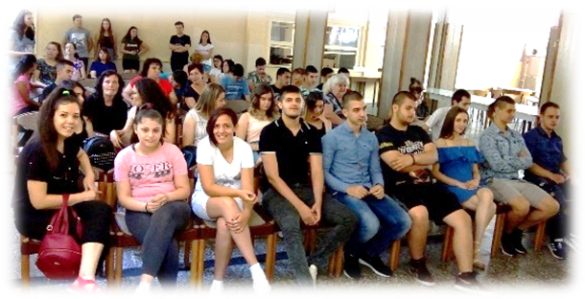
- PA 5: An Efficient Region: Finalized all 19 projects, developing mechanisms for enhanced cooperation in various sectors like health, education, public services, social policies, and tourism.


- PA 6: Technical Assistance: Supported program implementation (monitoring, project support, communication) and prepared for the 2021-2027 programming period.

Overall, the Interreg V-A Romania - Bulgaria Programme successfully fostered cross-border cooperation and delivered tangible improvements in various areas, benefitting citizens on both sides of the border.
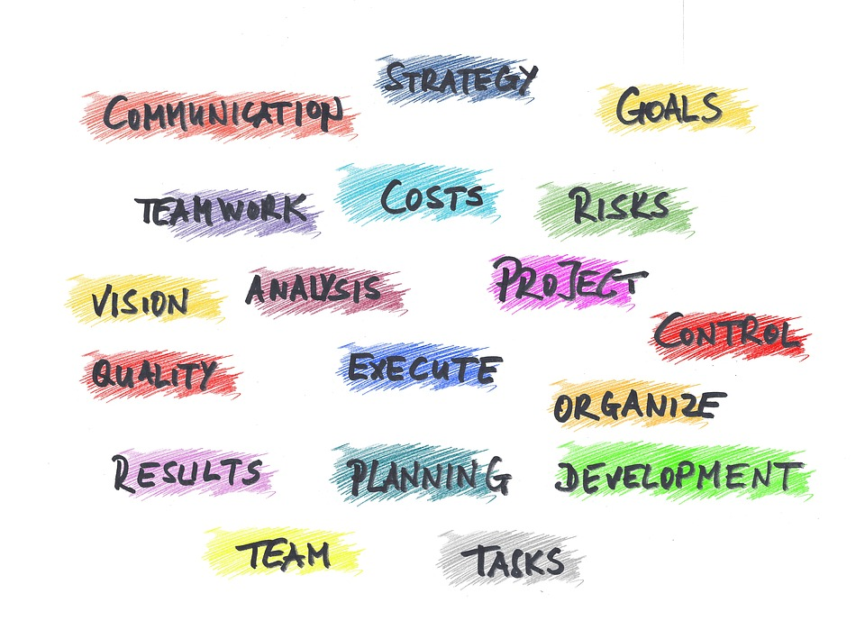
All relevant information is available on: www.interregrobg.eu
Follow us on social media:
https://www.facebook.com/RomaniaBulgariaCbcProgramme?ref=ts
https://twitter.com/ROBGProgramme
https://www.youtube.com/channel/UCtgRgCcdOK5D2ZsBJrMPXew/videos
https://www.linkedin.com/company/interreg-romania-bulgaria/
https://www.instagram.com/interregviarobg/

